APPENDIX C

Transcript of an interview with Louise Kent - Student Ambassador, Outreach
Louise - Let me just explain the current structure of the recruitment sector of Plymouth University. We all work under the umbrella of student services. We have 'Recruitment' and 'Outreach', which are the two departments that work together to recruit people to the university. Outreach works specifically with a certain brand of people - people who come from low income families, people who are disabled, ethnic minority groups and adult learners. So very specific groups of people. Whereas 'Recruitment' is the marketing side of it. So they're the people that go out to the UCAS fares and do all that kind of stuff. Outreach splits itself into different categories. I work specifically with the Arts faculty. My job is to recruit people that Outreach target to courses within the Arts faculty. To do this we'll go into schools, send academics into schools, and bring people onto the campus to give them an idea of what student life is like. All of outreach work with the same set of targets to recruit certain numbers of the different groups of people I listed earlier. The recruitment sector target everybody, but ours is specific, so we will do what is necessary for all of our faculties in order to recruit people from all of these different backgrounds. There are a number of target groups that we know have a large population in this area - people who have low incomes, people who's parents have never been to university etc. The way that we judge that we're hitting the right targets is to get every student we work with to fill in a form (see Appendix B.). This information will then be collated to work out if we're hitting our targets of recruiting from each of the groups. I hope that gives you a good background into what we do.

Chris - That's brilliant. I guess what what we want to know is how you go about this. What sort of things to you do when you find the groups of people you're targeting.

Louise - It depends. For Arts specifically, we partly work with the schools, so if one of the schools in the university says we want to find people for Architecture, we ask them what things they do that might be interesting for young people, or for the people we are targeting. They will then decide on an idea. So for example, for Architecture we ran an event which involved getting current university students and students from local secondary schools together. They worked one day in the school and one day at the university. to give them a bit of a bond, and to see the university, work on a project with those people, and then have a chance to present their projects. It's aimed to be quite fun and we try to keep things quite vibrant and exciting. We try and raise aspirations and encourage them to push to get a place here. A lot of people we work with are on a C-grade boundary so we try to give them the extra push to get the grades they need. Almost anything we do will involve a campus tour, meeting students, seeing a lecture theatre, seeing a seminar environment, that kind of thing. This is all to see what university is like, usually from the view of one subject, but that depends on who is running the session.

Chris - So for every situation, is there some sort of workshop involved?

Louise For the majority it will be either a workshop, but for the more general sessions, they will do more presentations followed by an activity. We find that for specific subjects, it's much easier to do a workshop because we can show exactly what the university offers for that subject.

Chris - So are most, if not all, of the workshops run by students?

Louise They are usually run by academics, depending on who's available and the subjects we are looking at, and it will be supported by myself, or one of my colleagues doing all of the background work, filling places, getting everything set up, and then the students will do most of the interaction throughout the day, because they're the important people to talk to.

Sam - Obviously there is some sort of budget involved. Could you give us any idea of how much you normally allocate to events?

Louise It depends on which part of the university are holding the event. So for example Science and Technology will have a budget, Arts will have a budget etc. The Science and Technology faculty is bigger out of the two. I can't give exact figures, but if we were looking at a fairly large event you are probably looking between one and two thousands pounds for an event that maybe a hundred to two hundred people will turn up to.

Chris - That's great. In terms of what we can do, we are looking into creating a campaigns company that campaigns both online, and in the physical world. We were looking at making fun interactive objects and installations, and placing them in public spaces to get people to interact with them and, in doing so, promote products, services, events and brands. From the research we have completed so far, there isn't any businesses that are doing this in the South West. An example of what we do is an interactive, large scale floor piano, that plays notes when people step on it's keys. It doesn't have to necessarily relate to the brand, it just has to catch their attention. So we was looking at how we could maybe do something like this for your events to promote courses.

Louise - Yes, absolutely. We quite often have a lunch or break period where students are in a space all together. Everyone loves a gimmick, and for us that is a major thing. That is why merchandising goes down so well. We always ALWAYS get asked for things like Plymouth University branded pens. So anything that is a quick hit or that students love is great. We usually work with students from around the ages of 13-17. They love anything that's a big hit, so actually that sort of thing would be great, as long as it has a message that sticks. Because for us it is really important that, although it does not necessarily have to be life changing, it has to be something that they will remember for a reason. For us there would absolutely be scope for this type of thing. We spend a lot of the time in the Roland Levinsky crosspoint space, so an installation there would be great. Also, we have lots and lots of different workshops going on and they are subject specific, but if there was something that could be used and changed for each subject, that would be good.

Sam - There's also course websites that we wanted to ask about. Our course has it's own website, but we wasn't sure how many other courses have that type of thing. And I was wondering if you could give us an insight as to whether this is something that other courses would be interested in.

Louise - We're currently working on the 'Outreach' part of the website. The university are currently in the process of changing the format of their website. But I don't think many other courses do have a website that we can send people to and certainly that is a big issue. So if we had somewhere to send people that would be amazing.

Chris - As it stands all of the courses have a page on the Plymouth website, but maybe we could look into giving each course their own website to give them an identity, and hopefully generating higher popularity.

Louise - I think you'll have to talk to the branding people about that. I know that we [Outreach] are not allowed to stretch outside of the [Plymouth University] brand. So we can't have, for example, an 'Arts faculty' website, unless it is plymouth.ac.uk/something, because we have to be kept in that brand. We have to be very careful about the branding. We are looking into having our own branding under the Plymouth University brand to give us more of an identity.

Sam - In terms of where go from here, do you have any ideas on how we might be of service to the university as a whole.

Louise - I would need to know exactly what you can do, and then if I send that around my department, I'm sure some ideas will come up as to how we can utilise you and for the sorts of things we need as a whole. It would be nice if it was something that wasn't just Arts specific. I'm willing to try it out as Arts first, but if this is something that is going to work for us, then obviously the whole department will want in. We've got four different faculties. We have six different strands, so this could be something that benefits everybody. So if the message was quite generic it would be good if we could use it in a few different areas. So, if you could show me something in the form of some ideas, that would be great.

APPENDIX D

Outreach Target Form
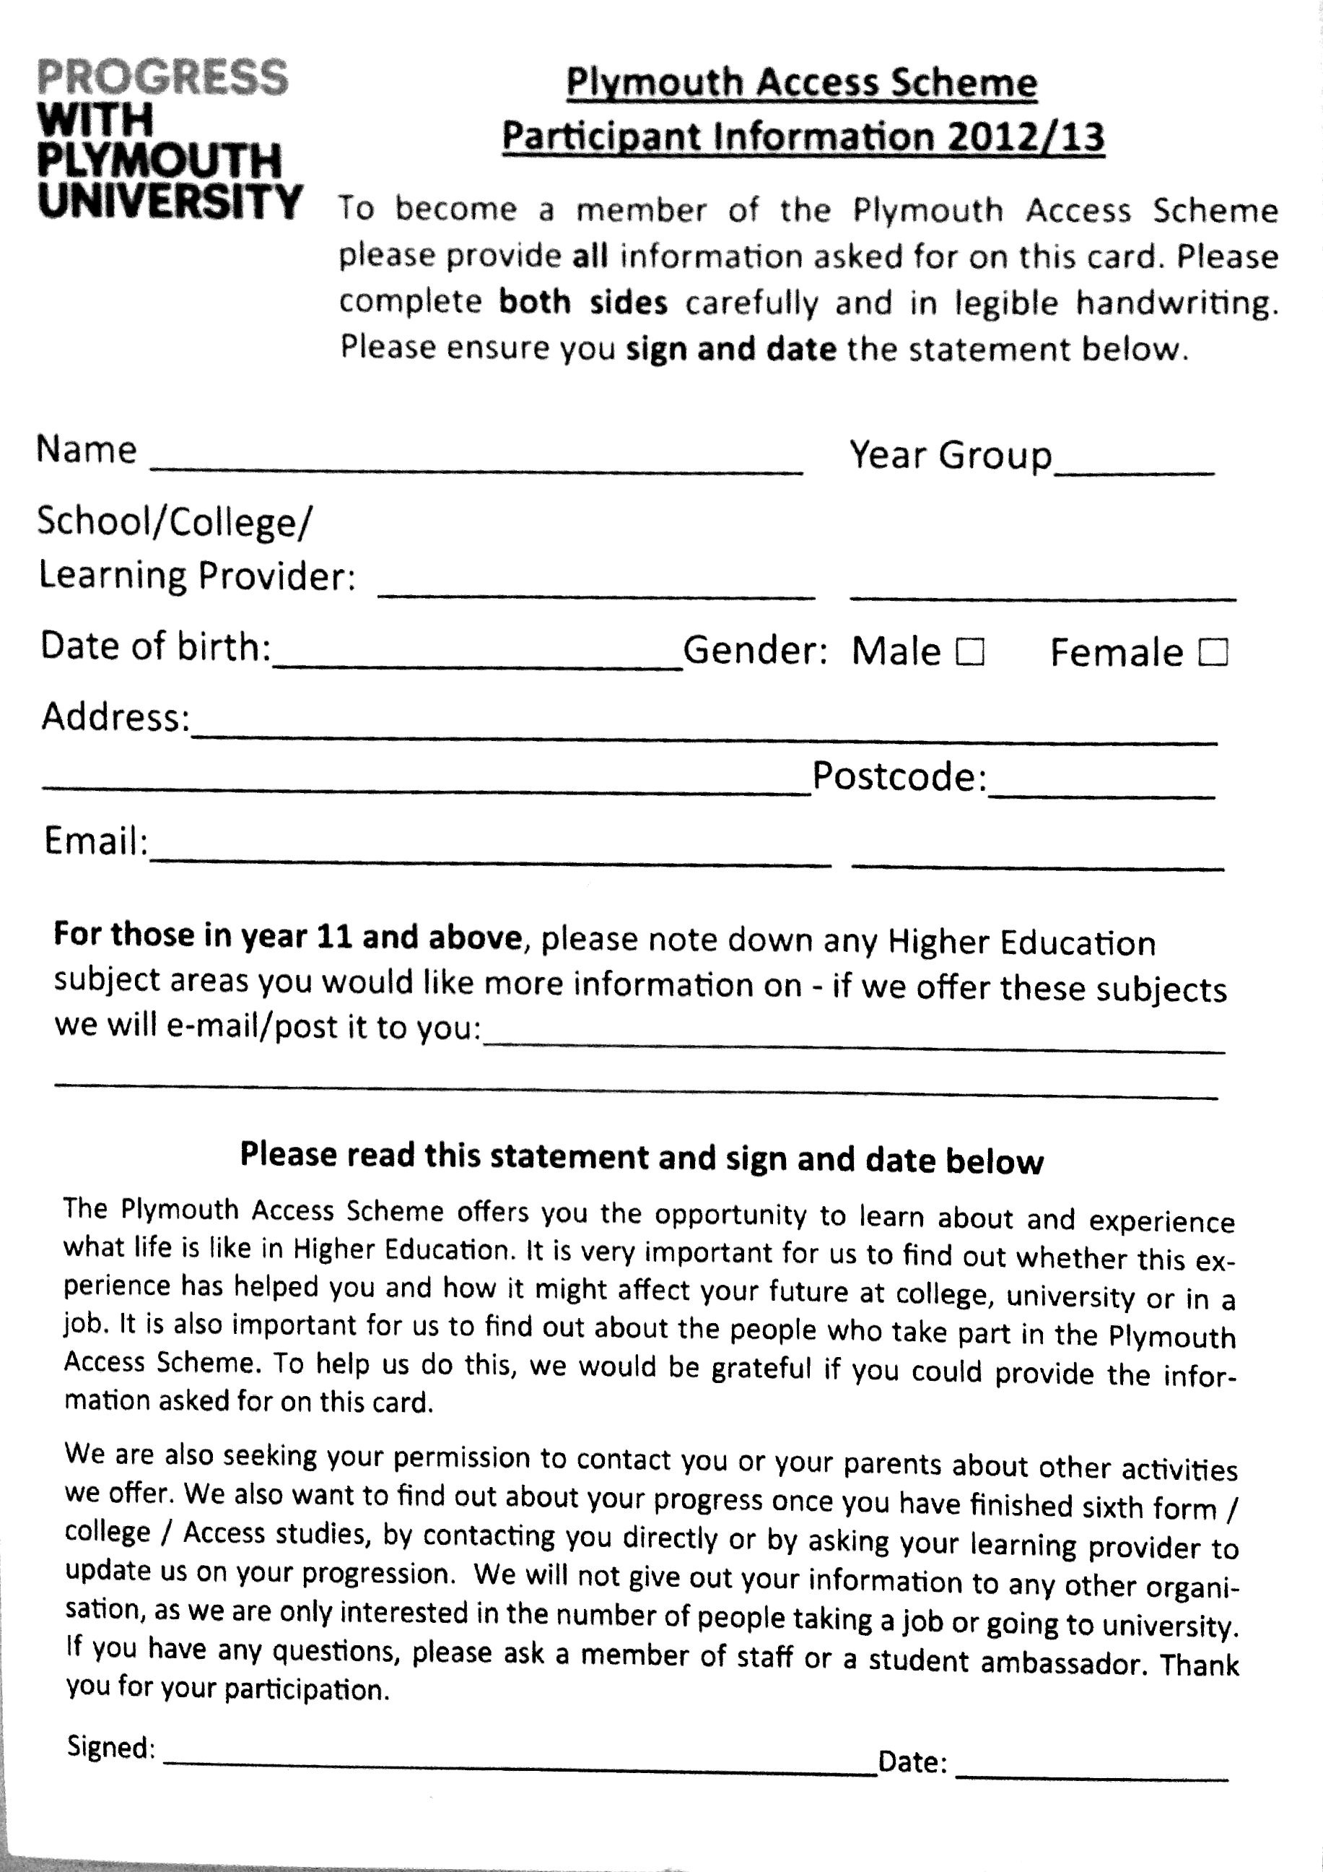
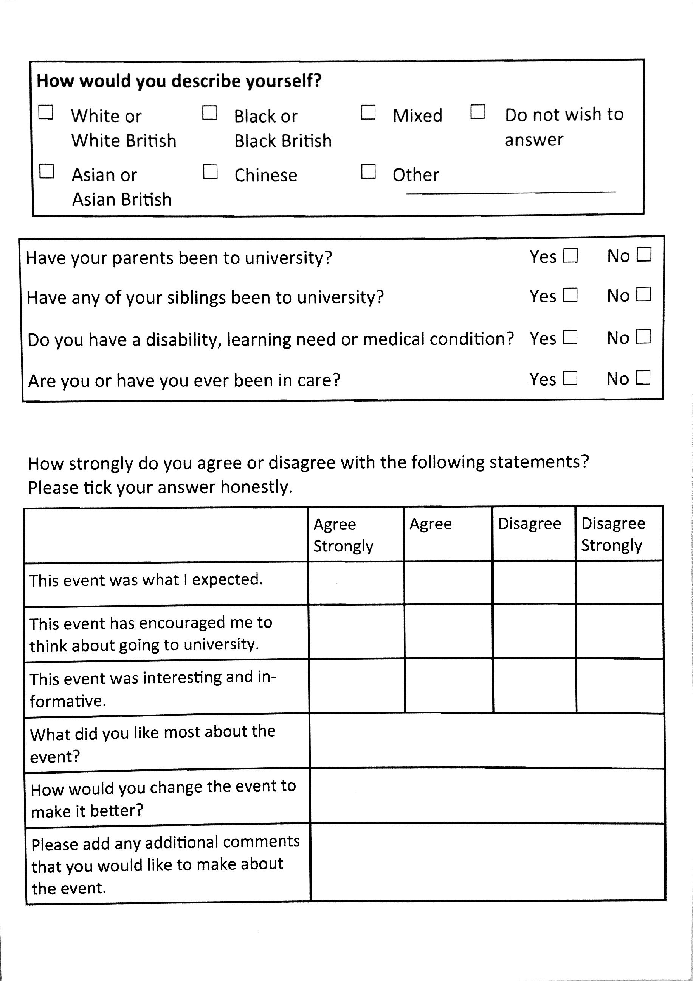

APPENDIX E

Emails from Christian Cooke - Research Director, Elixel

Hi Christian,
I’m a DAT student, currently working on the venture culture module. If possible, could you give us some guidance towards pricing structures? We are a team of three people developing creative digital campaigns for clients in the SouthWest.
Could you give us some advice on what you charge as a company in its third year?
Thanks for your time
Chris

Hey Chris,
You have to work out pricing structures back to front. First figure out your outgoings for each month, also look at what you want to pay your team members each month, and add on a profit margin so your company is profitable. Once you have this figure you see how much you need to make each month/year. There are on average 20 working days a month, and you probably won't have client work on each and every one of these days, so say 15 days. Divide your monthly costs by 15 and it should leave you with a figure of your 'daily rate', which is what you use as a base. You then calculate realistically how many days it will take to perform a project and multiply this by your daily rate. Voila!
I believe this is how I calculated things in VC, this is just off the top of my head! This is pretty much the formula for every year of the company, except your outgoings and profit margin should be increasing each year (more wages, bigger expenditures etc).
I hope this helps :)
Cheers
Christian

APPENDIX F

Emails from Alex Ryley - Managing Director, Mutant Labs

Hi Alex,
I’m one of the DAT students on the venture culture module. If possible, could you give us some guidance towards pricing structures? We are a team of three people developing creative digital campaigns for clients in the Southwest. Could you advise us on what you charge as a company in its third year?
Regards
Phil Rose

Hi Phil,
Thanks for getting in touch. Hope the module is going well!
I can't give exact prices, but I can give you a general overview. Probably easiest to gauge things on a daily rate. Daily rates generally tend to range from £200 / day to £600 / day, depending on level of experience and location. Freelancers and small companies often sit nearer that bottom range, whereas experienced freelancers / experienced studios in bigger cities can be closer to the top of that range. Generally the closer to London or bigger cities you go, the more the rates go up.
It also depends on the type of work (mobile/web/games etc.) and also if it is bespoke / high quality or cheap and cheerful. High quality stuff usually comes at a premium.
I hope that is of some use!
regards
Alex

APPENDIX G

Transcript of interview with Elaine Budd - Project Manager, Prensus Limited
Elaine - Ok, tell me what you're up to and what you're trying to do and I'll do my best to help, if I can

Chris - Well thanks for calling us. I've got my two colleagues here as well, Phil and Sam. Basically, we're finishing our final year at uni. In the next couple of months we're looking to set up a creative agency. We're contacting with you because we're looking to focus on campaigns and events, and maybe some installations as well, in the Southwest. So I was wondering, first of all, if I could get some information about your background and what you do?

Elaine - Yes of course. I started my career in marketing, and I'm getting on a bit now unfortunately. So I started a web company in the beginning of 96. Web wasn't very widespread then and mostly used by 'techies' and, especially in the west country, not many people knew about it. So what was our strength in terms of setting up early? The weakness was that not many people knew what it was all about so I ended up doing an awful lot of work in the Southeast. The web company grew to about 12 or so staff with contractors as well. We were based as the Tamar Science park and our biggest contract was with British Home Stores International and we did their online supply chain. Basically all of their franchises across the world, Middle-East and Eastern Europe ordered their stock via this site. Now the reason we were early was because we could see how important this could be, the internet as a thing, not just a technical system. I sold that company in 2004. Now I work as a project manager, which is what I did for that company anyway really. I get involved in a wide range of things because projects are projects. If you've got the project management skills it doesn't matter whether its a design project, or a build, or an event. So I work on a range of projects, from events to economic development, to skills initiatives. So a real broad brush. I do have kind-of-a creative background because the one company I set up, was looking at solving business needs so basically its all about relationships. So I'd build a relationship with a company, and not only would they want an IT system, but maybe new branding, so I'd work with design agencies to develop the branding, to apply that to any business solution that we were doing, and then you'd get asked for printing. So I ended up with quite a few different companies around me, to provide a complete solution. So, a lot of work with agencies.

Chris - Essentially we're looking into promoting brands, products, services and events. So we're looking at making mobile websites, data visualisations and applications.

Elaine - So a real suite of services for business then?
Chris - Yes, and we wanted to do some interactive installations as well. For example there's an installation where they had a staircase and they turned it into a giant piano so every time you walked on the steps it played the sounds. There was an escalator next to it and the purpose of it was to get people to use the stairs more. They obviously succeeded in that, because people used the steps a lot more than the escalator even though it was right next to it. So in that sense, that was more to encourage people to use the stairs. We wanted to find some cool ideas that we could do with technology and to promote brands and products with it as well. We really wanted to know if you know anything about the levels of interest in the Southwest for this sort of thing, and if there is a demand for it? We heard that you get involved with the graduation fair as well.

Elaine - No I don't do much for graduation. I mentioned that to Dawn when I responded. I'm an independent project manager so I do some work for the for the university but I also do some work for the chamber and the city, etc. I do some work for the university, but the events I get involved in tend to be more community based. Lisa Phillips has led on the graduation, but the company that has done that is a company called Chaos Productions. They do the putting together the event in term of marquees, staging, lighting, and all of the associated kit.

Chris - Ok, thats brilliant. From your experience of the events you've managed, have you seen any swaying towards using… because we're basically going towards this whole wow factor with everything we do. So it would be like one-off digital installations or campaigns to capture peoples attentions and to, if it's a product, promote their product, and the same with services and events. So we were just wondering if there was…

Elaine - So sort of big campaigns for events and upcoming events? I know a company in Exeter that does the outsourcing for events. If you're putting on an event they'll either manage the whole thing, in terms of putting together the conference pack, the venue, the lighting, the staging, the web. They do the whole lot. Or they can just provide campaigns to market the event. Now, they're not based in Plymouth… the sort of events that you're going to be looking at doing, I suspect, are going to be closer to Exeter/Bristol rather than Plymouth.

Chris - Ok, so is there more of a market there for this kind of thing?

Elaine - I would think so. I'm more than happy to put some thoughts down on paper for you and some contacts. I'm afraid the creativity that's displayed in the city tends to be more on the artistic side of things rather than the mainstream, which is something that has frustrated me for some time. I organised a launch for Respect at the University last week and we had a range of people from across the community. So it included business people, arts people, police, fire. A real mix. And we had confetti-cannons going off, and dancers. The dancers were scantily clad but culturally accurate. It was beautiful. It's really interesting to see people's reactions. They're not used to having that kind of creativity in front of them.

Chris - That's the sort of effect we were going for.

Elaine - What's interesting was, because I was actually operating some kites (it was all hands on deck) so I was operating some kites on the first floor of RLB, and it's really interesting to see peoples reactions. It takes away peoples barriers. It suddenly becomes 'not' business, and they're not quite sure, so I'm thoroughly supportive of what you're trying to do. So I think you've got to pair up with some people who are equally as visionary, if you were going to do anything in Plymouth… Now there is obviously the city of culture bid that has been produced, and that should, I hope, encourage some more creative thinking. And therefore I would hope that people who are getting involved with events would be therefore keen to display some creative thinking in order to support that kind of initiative… There's other interesting things such as the 'Plymouth Making Waves Project'. Are you familiar with that?

Chris - No, I've not heard of that.

Elaine - They've done it in various other cities, where cities have sculptures on a theme. People will decorate them, they'll form a trail. Plymouth is doing something on marine life, working with various companies to produce sculptures of marine life that will then be decorated. Hopefully, I would like to think, it going to be produced in materials that demonstrate each companies skills, so maybe composites from the marine industry. And then community groups and artists will decorate them. They'll create a trail around the city and then they'll be auctioned-off to raise funds for an environmental project. It is a replication of another idea, it's not innovative but it's showing that people are prepared to be just a little more creative.

Chris - So Plymouths on the, sort of, creative cusp? It's not quite there yet?

Elaine - Yes, it's becoming more mainstream generally. There'll be stuff, and there's talented people around. But you'll find the creative stuff is a bit more 'fringe'. It's a bit more at the experimental end, where you have a particular audience. It doesn't move into the more mainstream. However, that said, people like the media innovation network, the company I mentioned in Exeter, event companies, maybe looking for ways of gaining attention for events or products, or whatever, in a more creative way. So I guess really I just need to put my thinking-cap on and think about a range of contacts for you.

Chris - That would be really helpful

Elaine - Yes, I'd be happy to. I think what you're doing is great and I'd like to see more of it. At the moment I don't have any funding. Are you familiar with the 'Respect' festival? It takes place in the city. It's been done on a shoestring for about 14 years and it's about celebrating cultural diversity and difference. This is what I was launching last week. It takes place in October, and there's a very serious message around it because it's organised by the Racial Equality Council. But the University are now hosting and supporting it. It's got a theme that runs through the activities that they do, called 'Step Up for Respect' which is about saying 'What are you going to do to stand up for peoples rights', etc. The associated artwork, installations, the parade that will go throughout the town, will reflect a theme. This year the action is 'flying'. So its going to be 'Flying with Respect'. We've been talking with departments, including the 3D and arts departments about making these things. When do you actually finish your course?

Chris - We don't finish fully until the end of June, so we're looking to start up pretty much as soon as we finish.

Elaine - I'm wondering whether… wouldn't it be great if you could do something for that.
Chris - Yes, to start we just need to get out there and get noticed, so that sort of thing would be brilliant.

Elaine - Yeah, that's the thing. Sometimes when you first start a business you have to almost give stuff away a little bit.

Chris - From the research we've done we've come to accept that. We need to get a portfolio together and to do that we need to do that sort of thing.

Elaine - Yes, that's one of the things I would certainly recommend. You look for some high profile events and you offer your services, and you see if you can make a splash to get yourself noticed. I'll send you all these details. The reason I'm thinking about Respect in October is, or something you can do in the lead-up to promote it, is that they're open to creativity because of the nature of the event.

Chris - I suppose it would provide a lot of positive feedback if you get involved with stuff like that.

Elaine - I'm just wondering if there's anything else I can help you to get involved in before June.

Chris - Well, everything you've said so far has been very useful. So if you can give us a link to, or a list of contacts that would be fantastic.

Elaine - Is there anything else I can do for you?
Chris - I think that's pretty much it. We're still finishing the whole process of doing the business plan…

Elaine - Well I'm more than happy to cast my eye over that because I've had a couple of businesses. The legal profession and the accountancy profession, you need them as tools but they're not the right people to advise you on this really. They're not creative. I'm more than happy to do anything I can to help. Your going to have to start getting out and networking, so I'll try to help open some doors for you. I'll out you in touch with some people and throw some information at you and you can take or dismiss what you like.

Chris - Ok, thank you very much for this phone call and for taking the time out of your day to talk to us.

Elaine - Ok well let me get some stuff on paper, we'll have an email to and fro, and we'll see where we go from there.

Chris - Ok, well thank you very much. Hopefully we speak to you soon.

APPENDIX H

Transcript of an interview with Martin Atkins, Francis Clark Chartered Accountants
Chris - Hi, I've been given your contact details by the Plymouth Formation Zone. I'm looking to start up my own Limited business with two friends from university and we need to find out about the procedure and the legal documentation we need, as well as how much all of this would cost.

Martin - Well, as far as getting things like company formation in place, accounting and the tax side of things, to get set up you're probably looking at £250. From the legal perspective, if you wanted to get a shareholders agreement in place, which we really recommend when three separate parties come together, I would imagine you might be able to negotiate around a thousand pounds approximately. It's likely to be slightly higher than that, which puts a lot of companies off getting an agreement in place. Without that in place, you basically run to the letter of the law.

Chris - yeh, we are definitely looking to get a shareholders agreement.

Martin - To be honest, it's fairly straight forward to get things up and running. There's the registration of the company house, and what we usually do is help out with book keeping and spreadsheets. It's the legal side of things that is a bit more expensive. I hope that's useful to you.

Chris - Yeh that's brilliant thank you.

Martin - With a limited company, annual statuary accounts, corporation tax returns will need to be completed and self assessment tax returns for each of the directors and the costs for that vary depending on how well your books are kept.

APPENDIX I

Formation Zone Pricing
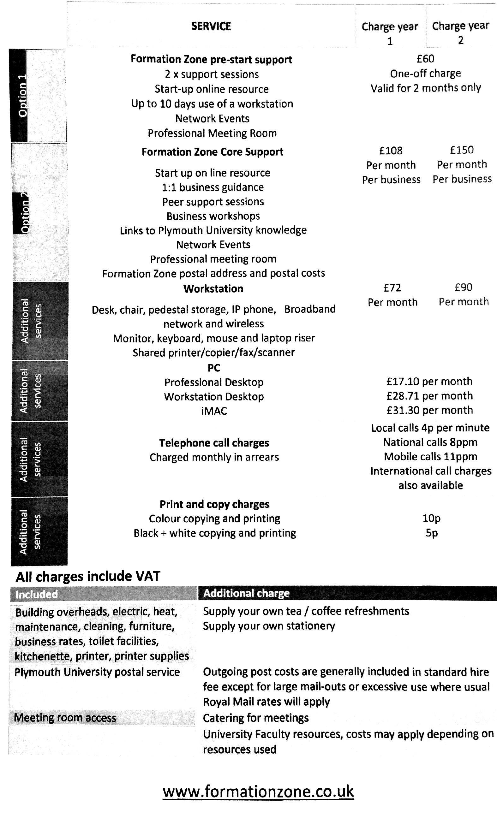

APPENDIX J

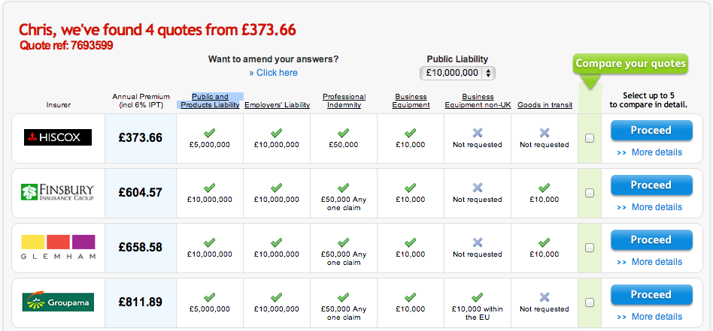
Business Insurance



APPENDIX K

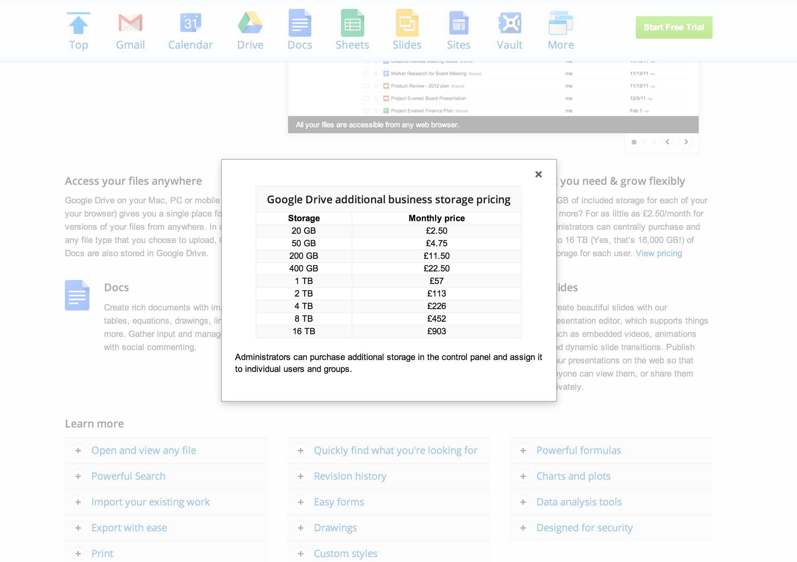
Google Drive Storage

APPENDIX L

Google Apps for Business

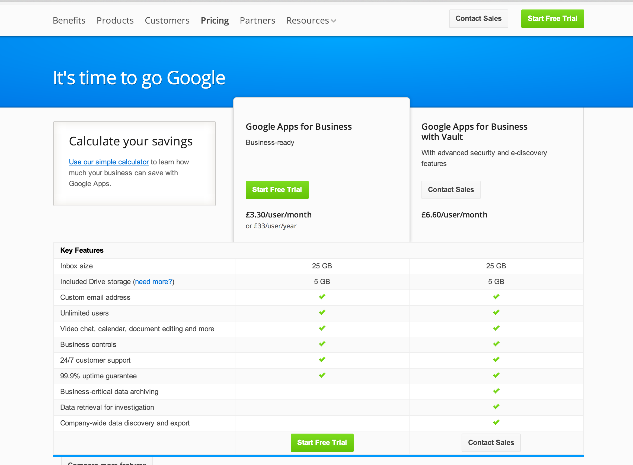

APPENDIX M

Free Agent

